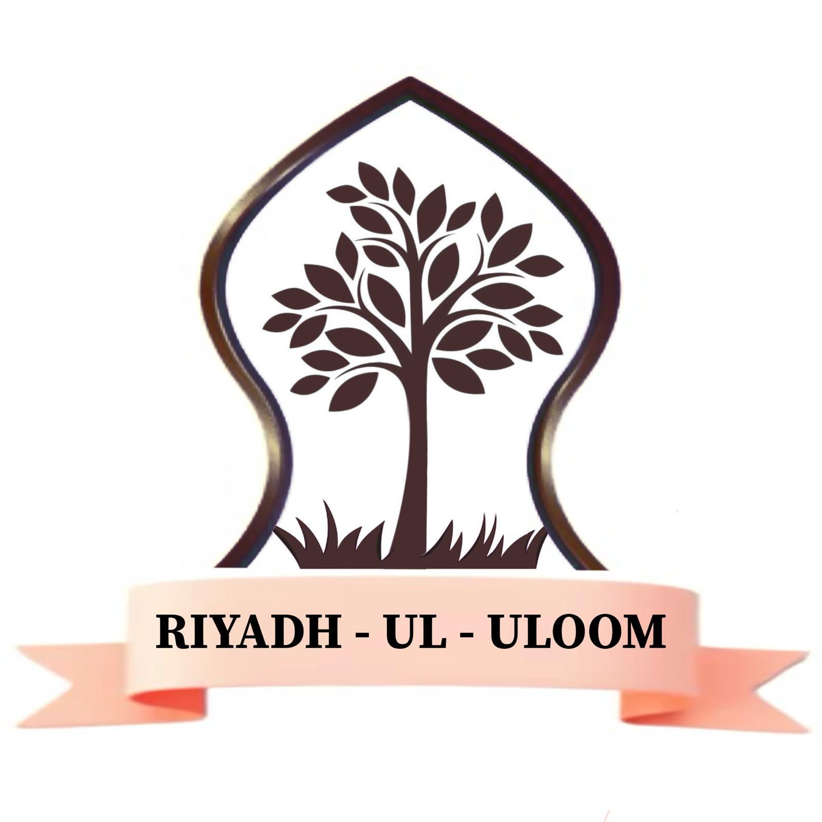
Riyadh Ul Uloom

Dear Parent or Guardian,
Thank you for choosing Riyadh ul Uloom.
We at Riyadh ul Uloom believe in providing a healthy, happy, productive and safe learning environment for your child. The welfare of our students is of primary importance to us. For this reason, it is essential for us to outline some key rules and regulations of the institute that you and your child will have to adhere by.
Parents play a vital role in the education of their children. To ensure that the children develop a thirst for knowledge and a strong love for their religion, it is very important that the parents cooperate with the teachers, so that the true values of the religion can be successfully instilled within the children. Although the institute can facilitate by educating young minds, unless this is nurtured and put into practice in the household, it will not be very effective. Parents should actively set a role model for their children in their worship, appearance, manners and interaction with others.
CODE OF CONDUCT
Guidance for parents:
- Parents/ guardians should remind their child (ren) to follow the Institute rules and discipline code.
- Parents/guardians should cooperate with the teachers to address any concerns regarding their child(ren)’s behaviour.
- The staff WILL NOT take any responsibility for your child outside class hours and it is the parents/guardians responsibility to ensure their child’s safety outside class hours.
- All monthly fees must be paid regardless of your child being absent or on holiday.
- All students must have all necessary books required daily.
- All homework should be completed daily whether in the form of writing or memorising.
- Riyadh ul Uloom reserves the right to expel any student if deemed necessary. Anyone expelled will have no legal authorisation against the institute. If for any reason a student has to be sent home then the parents/guardians/relatives will be informed by phone and will have to, without objection or delay, make necessary arrangements for the student to return home.
- Riyadh Ul Uloom rules may change without prior notice, you are required to follow them as soon as they are put into action.

Timings / Attendance / Absence

Secular Education: 9.00am - 12.30pm
Alimiyyah Studies: 1.15pm – 4.00pm

Parents are requested to bring their children 5 mins before class starts. Your time keeping and cooperation will help the teachers in providing the best quality of education to your child(ren).
Parents/guardians coming to Riyadh ul Uloom to drop or pick up their child(ren) will be required to park their cars in appropriate places. If parents/guardians who park cars incorrectly or stop in the middle of the road are warned or fined by local authorities, then the Institute will not be held responsible.
All students will be expected to attend class on site on a daily basis unless approved to join online. If your child(ren) need to take a day off for a valid reason, permission must be sought before that day, explaining the reason for the absence. Regular absences will not be tolerated and could result in detention/ suspension/ expulsion. We encourage the parents to take their children on holiday during the Institute holidays as they will experience a loss of knowledge if they take days off during term time.

Fees
Fees for the academic year (which consists of 11 calendar months) is £2200 , If parents/guardians wish to pay in instalments they may pay a minimum of £200 by the first of each month.

Uniform
Riyadh ul Uloom has adopted a dress code, which is in line with the Islamic requirements of dressing, in order to promote Islamic values and teachings. All students are expected to adhere to the dress code at all times.
- Black Jubbah
- Hijaab
- Flat shoes
Hijaab should be long enough to drape over the upper body and care should be taken to ensure that all clothing must loose and not see through.
Make-up is not permitted.
If a student falls short of the uniform or appearance requirements, a verbal warning will be issued. If there are repeated failures, the management will take further action by calling parents in for a meeting.
Behaviour / Etiquettes
- In cases where the students unacceptable behaviour remains unchanged parents/guardians will be notified by a member of staff, given detention, suspended, expelled.
- Any insult, to teachers or staff of the Institute, will be judged as inexcusable and any student/parent found guilty of such behaviour will be liable for dismissal.
- If parents have any complaint whatsoever, they must ensure that it will be made in writing directly to the management. Under no circumstances must the teachers be approached or intimidated directly or at their residence in anyway. If any part of this agreement is broken, then parents/guardians are taking responsibility for the consequences, which may lead to the suspension/expulsion of their child.
- If the child damages any institute property then the parents will be liable to replace it or pay the costs. If any child damages the carpets or sticks chewing gum on it then heavy fines shall be enforced.

Prohibitions
Students are not allowed to bring the following items to the institute:
Mobile phones, MP3 players, smart devices (smart watches, smart rings, smart glasses etc) cameras, toys or any item unsuitable for the classroom environment.
If a child needs to bring in a mobile phone, it must approved by management and handed in to a staff member.
Any items confiscated during lessons will only be returned to the child’s parent/guardian.

Conclusion
The primary intention of the code of conduct is not to punish students but to instil in them the need for order and discipline and to facilitate constructive learning. It is hoped that this code of conduct will inform the students the way in which they should conduct themselves in the institute. It will set a standard of moral behaviour, promote self-discipline and exemplary conduct. Parents must support the institute and ensure that their child observes all institutes rules and regulations and accept the responsibility for any misbehaviour on their part. On part of the institutes management every effort will be made to minimize disciplinary problems by embarking on proactive advice.
Please be reminded that parents and pupils who refuse to follow institutes rules can result in a child’s expulsion from Riyadh ul Uloom.
It is extremely necessary to abide by all the above and future rules and regulations. Riyadh ul Uloom reserves the right to implement new rules at any given time. If there is anything you would like to clarify, do not hesitate to contact us.

Thank you in advance for your cooperation.

